*Project Timeline*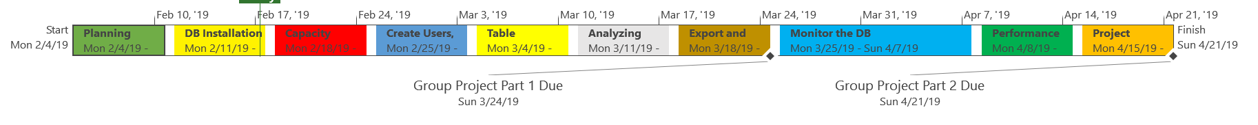

The above project time line identifies the allocated time for completion of each task.

*Project Schedule:*

Below is the project schedule that identifies the schedule of tasks and who will be responsible for completion. This Gantt chart shows the timeline for each milestone, task, the names of the project resources assigned to each task and the proposed start and end date for the entire project. For this project, there are ten milestones and each milestone will be worked on sequentially. The end of each milestone marks a true success in our project and ensures that every task in the project is completed on time with a great quality. 